# **How To Install Git On Windows**

**Important Commands For This Chapter:**

* init
* status
* add
* commit
* log
* config

1. Download Git from here <https://git-scm.com/download/win> .
2. Run the installer.
3. Click “Next” until you found “Install” button. About the previous settings before “install” button, just leave it by default, does not need to change anthing.
4. Continue install Git until it finished.

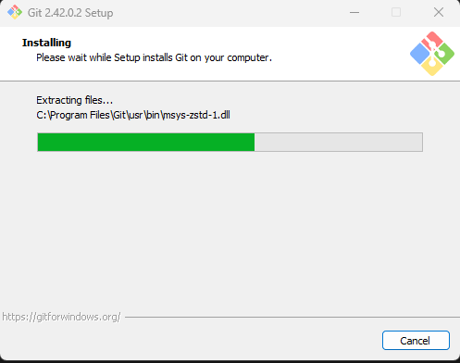

1. Click finish and its done.